Name: Huy Minh Dinh

Student Number: 7360174

**MATH255 – Autumn 2023 Computer Lab – Week 8**

1. (a)

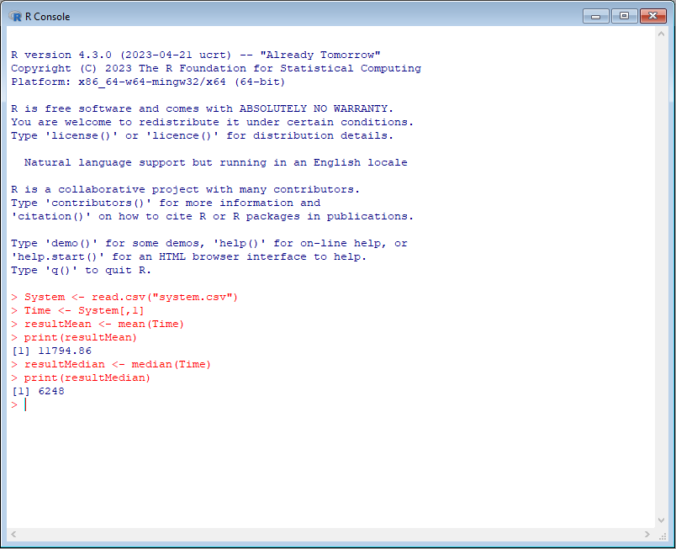

We have verified that the mean value of the first column (11794.86) is larger than its median value (6248).